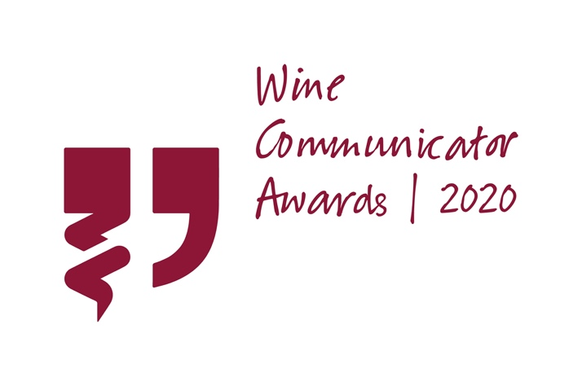
Entry Form: Best Wine Publication (Consumer)

This is the entry form for the 2020 Best Wine Publication (Consumer).
Entry and judging criteria can be found on the WCA website HERE.
Please ensure you complete all sections (noting word limits where they apply) by typing under the relevant headings of this application form.
Any additional and supporting materials can be submitted as part of the online entry process.
Alternatively, supporting materials can be:

- Sent electronically to the following email address: wca@winecommunicators.com.au, OR
- Sent as a hard copy to the following address: Suite 5/181 Gilles Street, Adelaide SA 5000
Entries close Friday 28 August 2020.
Good Luck!

Entry Form: Best Wine Publication (Consumer)

Please complete ALL SECTIONS below, failure to do so may result in your entry not being considered.
SECTION 1: PERSONAL DETAILS
Applicants Full Name:
Nomination Name:
*NOTE: this is the individual or business that will officially receive the Award (should the entry be successful)
Organisation:
Position:
Nominee Contact Number:
Nominee Email:

Nominee Social Handles:
FACEBOOK INSTAGRAM
TWITTER LINKEDIN

SECTION 2: QUESTIONS & ANSWER

1.Descriptive summary of the nominated publication. This may be used for PR purposes (200 words).

2. What are some of the unique design and writing elements the author(s) consider important in the publication? (200 words)

3. Describe why the campaign was undertaken and how it added value to the organisation/product. (200 words)

4. Please provide details that demonstrate distribution and industry support for the entered publication. For example, circulation data, testimonials or reviews (200 words).

SECTION 3: SUPPORTING MATERIAL

Please send 4 copies of the nominated publication to the following address:
Wine Communicators of Australia
Suite 5/181 Gilles Street
Adelaide SA 5000

**We are unable to consider your application without a physical (or digital) copy of the nominated publication.

Please attach the following supporting material to your on-line entry form.

- A high-quality image to represent the person/organisation being nominated.
This may be used for PR purposes.

If you experience technical difficulties, please email directly to wca@winecommunicators.com.au

