MENTOR Background Information: 2019 Wine Industry Mentor Program
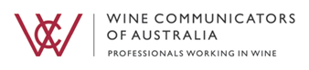
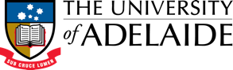
The WCA Mentor program aims to team experienced wine professionals with young, up and coming wine industry members to provide them with guidance and direction to help them become better wine communicators now and into the future. The program is an investment in the future of wine communications and aims to provide its future talent the opportunity to learn, refine their skills and interests, and explore further opportunities by tapping into the experiences and insights from a current day leading wine professional like yourself.
To assist us in pairing you as a mentor with a mentee, we ask that you provide us with the following information about yourself.
PERSONAL DETAILS
Full Name:
Organisation
Current role:
Geographical Location:
Contact Number:
Email:
LinkedIn IRL (optional)

COACHING INTENTIONS

Why would you like to be involved in the 2019 Wine Industry Mentor Program? (200 words max)

What are the key industry insights, knowledge and experiences can you offer to a mentee? Dot points are fine.

Based on your past experience in the industry, what topics do you feel you could ‘add value’ to discussions with your mentee? You can select multiple answers.
- Career Planning
- Sales
- Leadership
- Marketing
- Digital Media
- Content Creation
- Business Planning & Strategy
- Work / Life Balance
- Workplace Challenges
- Other (please specify)

If selected for the program, what is your most preferred way to contact your mentee?
- Face-to-face
- Phone
- Skype (or other equivalent)
- Email
What is your second most preferred way to contact your mentee? Select one answer
- Face-to-face
- Phone
- Skype (or other equivalent)
- Email
Please provide the following (to be used for PR & Marketing purposes):
- Professional Bio
- Headshot picture – High resolution (pdf, jpeg).

